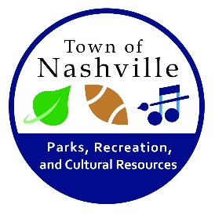**Town of Nashville Light Fight Entry Form**

All homes and businesses within Nashville City Limits are eligible

Name:____________________________________________________________________

Address:__________________________________________________________________

Daytime Phone:________________________ Evening Phone:_____________________

Judging will take place on December 15, 2018. Homes will be judged based on curbside appeal only. Judges will not enter the property. An entire set of rules can be found on the promotional flier.

Each entry will be judged against others in each division. **Please circle the division you are competing in:**

* Business
* Residential

Each entry will be judged in one of these categories. **Please circle the description you think best matches your display:**

* **Religious** (best display with a religious theme)
* **Nostalgic** (most old-fashioned, best reminds-me-of-my-childhood display)
* **Clark Griswold** (excessive use of outdoor lighting and decoration)
* **Anything Goes** (no specific theme, but WOW)
* **Business** (Best business decoration)

**All participants will be entered in the Overall Grand Prize Category**.

Please sign here if you agree to allow photographs of your display to be used for promotional purposes by the Town of Nashville.

Homeowners/Business Owners Signature: __________________________________________________

Please return this form to the Town of Nashville by Friday, December 13 @ 5:00PM.