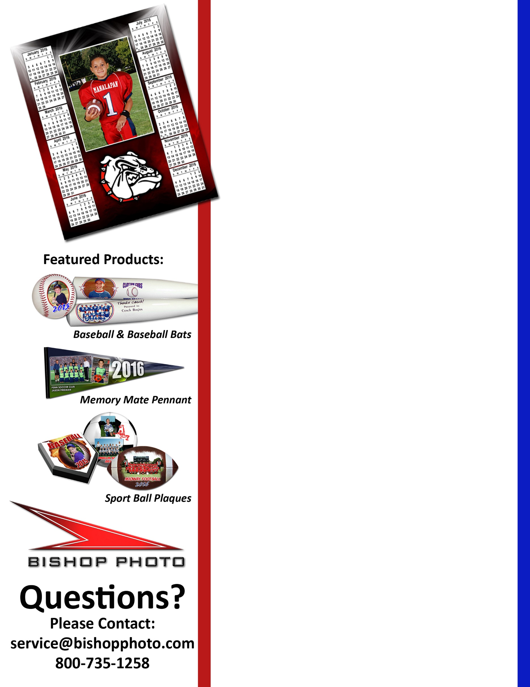

**Order your photos online prior to Picture Day and receive a FREE 8 x 10 Photo Calendar. *That’s a $20.00 value – FREE!***

**PICTURE DAY IS:  
Saturday, April 14th  
Nashville Parks & Rec baseball/softball pictures will be taken on   
Saturday, April 14th. Order your photos online prior to Picture Day and receive a   
FREE 8 x 10 Photo Calendar!**

**Go To:** **www.bishopphoto.com**

**Click on the “PRE-ORDER NOW” tab.**

**Your order form code is: NashvilleSpring18**

**Place your order and PRINT the receipt to hand to the photographer on photo day.**

**Your FREE 8 x 10 Photo Calendar will be added to your cart at check-out.**

***\*\*\* If you cannot print please write our confirmation # down on a piece of paper to give to your photographer.***